MATHEMATICS NOTES FOR PRIMARY TWO THIRD TERM 2015.
Measures
Lesson one
Time (revision work of primary one)
Telling time by the hour.
A clock face may have 2 or 3 hands. Emphasize the two i.e The minute hand and the hour hand.
The long hand is the minute hand.
The short hand tells us the hour.

The clock face has numbers 1 – 12
Note: 1 hour = 60 minutes
an hour = 30 minutes
an hour = 15 minutes
1 day = 24 hours
a day = 12 hours
A day starts at midnight and ends at ………………
Practice telling time by the hour using individual clock faces.

REFERENCE and MORE WORK:
Fountain Mathematics pupils bk 2 pg 146 – 152
Primary Mathematics for Uganda bk 2 pg 100 (check 33)

Lesson two
Telling time in half hours. (Revision)
Note:
In one hour the minute hand goes all round the clock face and these are sixty minutes, (60)
From one number to another these are five minutes. (You can practice counting in fives)

In an hour, the hour hand moves from only one number to the next on the clock face.
When the minute hand goes half way the clock face, the time is half past the hour.
e.g
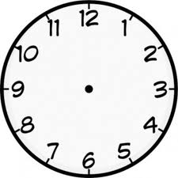

It is half past 1 It is half past 8 It is half past 3
It is past 1. It is past 8 past 3.

When it is half past the position of the minute hand is always 6. The hand is half way past the hour.
REFERENCE AND MORE WORK:
Primary Mathematics for Uganda bk. 2 pg 101.
MK Primary Mathematics bk 2.

LESSON THREE AND FOUR
Telling time (a quarter past)

Children will be helped to count the small markings between each two figures showing minutes.
When they count up to 15 minutes teach them the word a quarter past.

It is a quarter past 12. It is a quarter past 10 It is a quarter past five.

When it is a quarter past, the minute hand always points at 3 and the hour hand is slightly past the hour.
The proper movement of the hands is clockwise.

Tell the time practically before doing a written exercise.

Reference and more work:
E A E P – Primary Mathematics bk 2 pg 57 - 59.
Mk Primary Mathematics bk 2 pg 131 – 132.

LESSON FIVE AND SIX
DURATION
Duration is the time taken for an activity to be done.
Duration is got by subtracting the end time from the starting time.
You can also find out duration using a clock face. (This is the simplest method for the children)
Examples
1. Baby Norah slept at 1:00 o’clock and woke up at 3:00 o’clock. For how long did the baby sleep?
3 – 1 = 2
0 1 2 3
The baby slept for 2 hours.
Or 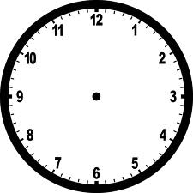

2. Dumba left school at 5:00 o’clock and reached home at 6:00 o’clock. How long did this journey take? 6:00 – 5:00 = 1 hour. Or

3. If today is Monday, what day will it be after 2 days?

4. A farmer started digging at 8:00am and ended at 11: am. For how long did he dig in his garden?
Write more word procedures showing duration. (Written exercise)
Reference:
Trs. own collection.

LESSON SEVEN
Revision of P.1 work
DAYS OF THE WEEK
Talk about Days of the week and months of the year.
A week begins on Sunday and ends on Saturday.

Write the days in full and in short.
Sunday - Sun.
Monday - Mon.
Tuesday - Tue.
Wednesday - Wed.
Thursday - Thur.
Friday - Fri.
Saturday - Sat.

Exercise revise table 7 and complete the table to show the numbers of weeks and days.
MONTHS OF THE YEAR
Months for the year and their days
January - 31
February - 28 or 29
March - 31
April - 30
May - 31
June - 30
July - 31
August - 31
September - 30
October - 31
November - 30
December - 31
Children will learn the rhyme.
- Thirty days has September, April, June and November.
All the rest have thirty one except February alone.
For it has 28 days or 29 in a leap year.

Reference and more work:
Mk Primary Mathematics of bk 2 pgs 133 – 134.
Primary Mathematics for Uganda bk 2 pg 40.

LESSON EIGHT
Calendar
Use the calendars in class or send for old calendars from home.

Let pupils observe / study the calendar and note the following;
The months shown
The next month
The month before the next shown.
The first and last day of the month.
Dates which are highlighted. (public holidays)
Reference
MK Primary Mathematics 2000 page 138.
E.A.E.P Primary Mathematics bk 2 pg 56

LESSON NINE
TOPICAL TEST
1. What is the first day of the week?
Sunday.
2. How many days are there in 3 weeks?
1 week = 7days
3 weeks = 3 x 7 days
= 21 days

3. Write these short forms in full.
Tue – Tuesday Aug – August
Wed – Wednesday Dec – December
4. How many months are there in one year? 12 months

5. Write two months which have thirty days. April, June, September or November.

6. How many hours make a day?

7. Show the time.
a) Two o’clock b) half past 7. c)quarter past 11 o;clock

LESSON EIGHT AND NINE
Telling time in quarter to:
The time after half past any hour can be told using “to”
When the minute hand points to 9, we say “ 15 minutes to or a quarter “to” the next hour.

The hour hand is slightly pointing to the next hour.
Example
i) ii)

It is a quarter to 3. A quarter to 7.
REFERENCE AND MORE WORK:
MK Primary bk 3 page 132.

LESSON TEN AND ELEVEN
Algebra
Algebraic equations involving multiplication.
- Emphasize recitation of tables to recall and be able to apply this knowledge when solving the equation.

Examples
5
1. x 3 = 15
= 15 ÷ 3 Check 5 x 3 = 15
= 5

2. x 4 = 12
= 12 ÷ 4 Check 3 x 4 = 12
= 3
When you are looking for the first gap, you divide the answer by the given number.
3. When you’re looking for the gap in the middle, you divide the answer by the given number.
8 x = 16
2
= 16 ÷ 8
= 2
10 x = 20
2
= 20 ÷ 10
= 2
Reference and more work:
MK MTC bk 2 pg 103
Fountain primary mtc bk 2 pg 114

LESSON TWELVE
Measures
Money
Vocabulary
Money change
Coins buying
Notes selling
Currency cost
Denominations price
Shillings cheap
Trade conversation
Barter crested crane
Bargain purchase
Money is what we use to buy things we need. It is in form of coins or paper notes with the value printed on them.
Background of money
People of long ago used to get things they wanted through barter trade ie exchanging different items because they did not have money.
(Talk about the advantages and disadvantages)

Indians introduced rupees. Afterwards, this money was replaced by the shilling which we use up to date.

LESSON TEN AND ELEVEN
Currency
Currency is the type of money that is used in a country. Different countries have different currencies.
e.g
Ugandan currency is shillings
Kenyan currency is shillings
Tanzanian currency is shillings
Nigerian currency is Naira
Rwandan currency Francs
American currency is dollar
UK currency is pound.

Uganda currency is in two forms.
Coins and paper notes. These are of different denominations.

Coins notes
Shs 50 shs 1000
Shs 100 shs 2000
Shs 200 shs 5000
Shs 500 shs 10,000
Shs 1000 Shs 20,000
Shs 50,000

Each denomination has features. Children will look at real money or specimen from newspapers.
Currency
Shs 50 coat of arm
Shs 100 a cow, coat of arm
Shs 200 fish, coat of arm
Shs 500 crested crane head, coat of arms
Shs 1000 coat of arms, crested crane
Notes
Shs 1000 kobs, coat of arm, monument
Shs 2000 fish swimming, monument, river, parliament, coat of arms
Shs 5000 nests and birds flying, monument, coat of arms, parliament, image of crested crane.
Shs 10,000 banana plantation, pottery, monument, waterfall, image of a crested crane.
Shs 20,000 river / lake, monument, cows grazing, coat of arm, image of crested crane, people holding a flag, coat of arms.
Shs 50,000 mountain gorillas, monument
Activity
Write the features of the different denominations.
T/Aids: Real money, text books, specimen chart.
Reference and more work.
MK Primary MTC bk 2 pgs 122 – 123.
MK Primary MTC Bk 2 pg 176.

LESSON TWELVE
Getting equivalent amount of money. (use real money)
Changing bigger denominations to smaller denominations e.g
a) Two coins of shs 50 are equivalent to 1 coin of shs 100.
Shs 50 + shs 50 = 100
b) Five coins of shs 100 are equivalent to sh 500.
Shs 100 + shs 100 + shs 100 + shs 100 + shs 100 = shs 500

Reference and more work:
Understanding Mathematics book 3 pg

LESSON THIRTEEN
Shopping
Vocabulary
Price list customer
Balance shopkeeper
Cost cheap
How much expensive
Change expenditure
LESSON FOURTEEN AND FIFTEEN
Shopping game
Using the shopping language: [TRS HAVE A MODEL SHOP AND SHOPPING LIST ]
Customer: Good morning / afternoon Sir / Madam
Shopkeeper: Good morning ……………………
Customer: May I have ………………………
Shopkeeper: Yes, you may.
Customer: How much does it cost?
Shopkeeper: ……………………….. e.t.c
Children will use the class shop and price list. They will discuss the price list and identify the cheapest item and most expensive item. (They will use the words “cheap” and “expensive” to build their understanding)

LESSON SIXTEEN
Buying and selling
Finding total expenditure basing on a price list.
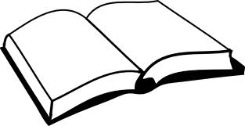
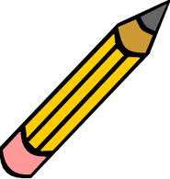
Example

A book a pencil a sweet
Shs 300 shs 200 sh 100.
Pupils will study the price list then answer the questions.
a) How much will you pay if you buy a pencil?

b) How much will you pay for 2 books?
One book = sh 300
Two books = sh 300 Or sh 300
X 2 + sh 300
Sh 600 sh 600
c) How much money will you pay if you buy a book and a pencil?
A book sh 300
A pencil + sh 200
Sh 500
I will pay shs 500 for a book and a pencil.
d) What is the cheapest item?
LESSON SEVENTEEN
Finding ( change) (subtraction)
Change is the money you get back when you give in more than the cost of the items you have bought. Example
You have a price list in a shop
A bottle of soda sh 700
A cake sh 300
Biscuits sh 500
A bun sh 100
a) If I have sh 500 and I buy a cake, how much will I remain with?
Sh 500
- sh 300
Shs 200
Joyce will remain with sh 200.
Reference and more work:
Mk Primary MTC bk 2 pg 126 – 7.
Fountain Primary MTC bk 2 pgs 142 – 144

LESSON EIGHTEEN
TOPICAL TEST
Match correctly
1. Money feature
Shs 200 cow
Shs 100 crested crane
Shs 500 head of a crested crane
Shs. 1000 fish
2. How much money do you have if you have 3 coins of shs 100?
Sh 100 + sh 100 + sh 100 = sh 300
3. How many coins of sh 500 make one thousand shillings?
Sh 500 + sh 500 = sh 1000
2 coins of sh 500 make shs 1000.
4. If one apple cost shs 600, how much will two apples cost?
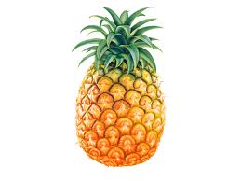
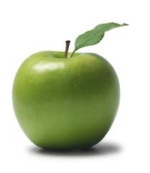
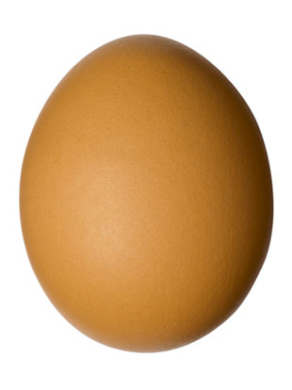
5. Study the price list.

Sh. 700 sh. 500 sh. 200

a) What is the cheapest item?

b) How much will you pay for 2 eggs?

c) What is the total cost of a pineapple and an egg?

d) If you have shs 1000 and you buy one apple, how much money will you remain with?

- What is the cost of 3 eggs?

LESSON NINETEEN
Measures
PERIMETER
What is perimeter?
Perimeter is the total distance around a figure.
Perimeter is measured in centimeters.

Find the perimeter of the shapes below.

P= s+s+s+s
P= 5cm +3cm +5cm + 3cm P= s+ s+s+s
P= 16cm P= 5cm +5cm 5cm + 5cm
P= 20cm

Reference and more work :
Fountain Primary Mathematics BK 2
Primary Mathematics for Uganda

LESSON TWENTY AND TWENTY ONE
Definition
What is area?
Area is the number of square units which cover the surface of a figure.

It is the space a flat surface takes up.
2. To build understanding measure area use things like match boxes, papers, e.t.c
Practical work
Cut small squares of paper of the same size and fit them on a larger square piece of paper. Use glue to fix them.
How many small squares are there in the larger square?
Compare areas of different objects.
Pupils will be introduced to counting squares covering a surface.
Examples:

= 10 squares
Find the area of the following figures by counting squares.
Area = 6 squares

Area = 10 squares

Reference and more work;
Fountain Primary mathematics bk 2 pg 159 – 160.
MK MTC bk 3.
Primary mathematics for Uganda pg 107 – 109.

LESSON TWENTY TWO and TWENTY THREE
Finding Area by multiplying
(Supplement the first exercise)
Multiply the number of squares across by the number of a square down words.

3 cm NOTE: Each unit is a cm.
4 cm
A = 4 cm x 3 cm
A = 12 sq cm.
Reference and more work;
Fountain Primary mathematics bk 2 pg 159 – 160.
MK MTC bk 3.
Primary mathematics for Uganda pg 107 – 109.

LESSON TWENTY FOUR and TWENTY FIVE
Finding area by multiplying when given length and width.
A = L × W
3cm A = 3cm × 3cm
A = 9 square cm
3cm

4cm
7cm
A = L X W
A = 7cm x 4 cm
A = 28 square cm

Reference AND MORE WORK
MK MTC bk 3 pgs 156 – 158.

LESSON TWENTY SIX AND TWENTY SEVEN
Algebric equations in division
Apply the knowledge of tables
Note: To find the dividend, you multiply the quotient (answer) with the division or you can use the multiplication table.
Example
18
1. ÷ 3 = 6 x 3
= 6 x 3 1 3
= 18 2 6
3 9
4 12
5 15
6 18
The missing number is 18.

2. ÷ 5 = 5 x 5
25
= 5 x 5 1 5
= 25 2 10
3 15
4 20
5 25
The missing number is 25.

Finding the division
You divide the dividend by the quotient.

E.g
1. 12 ÷ = 6
= 12 ÷ 6
= 2
The missing number is 2.
Activity from
Reference:
MK MTC bk 2 pg 105 -106
Fountain Primary mtc bk 2 pg 114.

LESSON TWENTY EIGHT AND TWENTY NINE
TOPICAL TEST
1. X 6 = 12
2. X 5 = 10
3. 7 X = 21
4. 11 X = 44
5. 15 ÷ = 5
6. 24 ÷ = 6
7. ÷ 7 = 2
8. ÷ 9 = 3
Word problem
9. What number do I multiply by 5 to get 30?
X 5 = 30
10. Think of a number divide it by 4. Your answer is 4. What is the number?
Reference
Primary mathematics for Uganda bk 2 pgs 52 – 53.
MK MTC bk 3 pgs 173 – 174.

LESSON THIRTY AND THIRTY ONE
MASS
Revision of mass using non standard measure.
Compare mass using non standard measures.
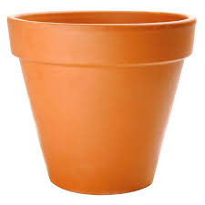

A
B
Which bucket holds more water?

TRICIA a) Who is heavier?
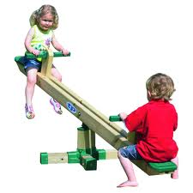 b) Who is lighter?
MICHEAL

Reference and more work:
MK Primary MTC Bk. 2 pgs 146 – 147.

LESSON THIRTY TWO
Introduce the standard unit of mass the kilogram (kg)
Emphasize that the standard unit helps to give accurate measurements.

Talk about the smaller units and their equivalent
1kg = 1000gm
kg = 500gm ( of 1000)
Refer to of 10 then 100 then 1000.
kg = 250gm
(Not easy to teach)
Talk about different weighing scales. Carry out a practical exercise of children weighing themselves using a weighing scale.
Note
As you carry out the exercise, emphasise the use of heavier than, ‘lighter than’, the ‘same as’ or none of them is heavier because they have the same weight.

Use another weighing scale which uses stones. (usually used in shops)
Let children weigh different objects.
REFERENCE AND MORE WORK
MK Primary MTC Bk 2 pgs 146 – 147.

LESSON THIRTY THREE
Converting units of mass
Note: To change from a big unit to a smaller unit you multiply e.g change from kg to grams.
Example
Pupils should know that 1kg = 1000gm
Change from kg to g
1. 3kg = g
1kg = 1000g
3kg = 3 x 1000g
3kg = 3000g
2. 4kg = g
1kg = 1000g
4kg = 4 x 1000g
4kg = 4000g

3. 10kg = g
1kg = 1000g
10kg = 10 x 1000g
10kg = 10,000g

REFERENCE AND MORE WORK
MK Primary MTC Bk 2 pgs 148 – 149.

LESSON THIRTY FOUR AND THIRTY FIVE
Add mass (and this can be given as early morning exercise because it is the same concept of addition)
Examples
1. 10kg + 13kg = 23kg
10kg
+13 kg
23kg
2. kg + kg =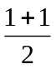 =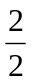= 1kg

3. (You can include numbers involving re-grouping for revision purposes)
16kg + 8kg =
T O
1 6kg
+ 8kg
2 4kg

Give some few word problems to help pupils read and interpret e.g
1. Sarah weighs 45kg and her sister Norah weighs 50kg. Who is heavier (or who is
lighter)?
Norah is heavier than Sarah or ………………………..
2. Find their total mass.
4 5kg
+ 5 0kg
9 5 kg. Their total mass is 95 kg.
REFERENCE AND MORE WORK:
Primary Mathematics for Uganda bk 2 pgs 50-52.
LESSON THIRTY SIX
Subtraction (can be done as an early morning exercise)
Examples
1. 18kg - 4kg =
1 8kg
- 4kg
1 4 kg

2. 4 2kg 3. 2 3 6 kg
- 2 0 kg - 1 2 3 kg
2 2 kg 1 1 3 kg
Give some word problems.
E.g
1. A sack of potatoes weighs 50kg. If 20kg of the potatoes are sold, what mass of potatoes will be left?
50 kg
- 20 kg
30 kg
2. 28 kg of sugar take away 14kg of sugar.
2 8 kg
- 1 4 kg
1 4 kg
REFERENCE AND MORE WORK
Primary Mathematics for Uganda bk 2 pg 52 – 53.
LESSON THIRTY SIX
TOPICAL TEST
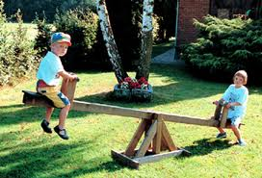 Wasswa
1. Kato

a) Who is heavier? b) Who is lighter ?

2. Change to kg
a) 7kg - g
1kg - 1000g
7KG - 7 X 1000g
7kg - 7000g

b) 4kg - g
1kg - 1000g
4KG - 4 X 1000g
4kg - 4000g

3. Which is heavier, a kilogram of sugar o a kilogram of grass?
None of them is heavier.
They have the same weight (equal)
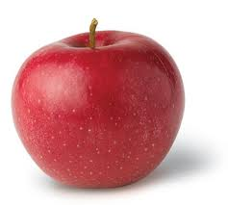
4. a) b) 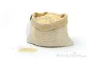
12kg 11kg

a) Find the total mass of the two objects.
1 2 kg
+ 1 1 kg
2 3 kg
Their mass is 23 kg

b) Subtract the mass of object b from object a.
1 2 kg
- 1 1 kg
0 1 kg
The answer is 1 kg.

MERRY X-MAS AND A PROSPEROUS 2014.

